# NALAIYA THIRAN

Professional readiness for Innovation, Employability, Entrepreneurship.

# NUTRITION ASSISTANT APPLICATION

|  |  |
| --- | --- |
| P.POOJA | 952419104022 |
| N.THILAGAVATHI | 952419104036 |
|  |  |
| N.SIVATHARANI | 952419104033 |
| T.MAHARAJA | 952419104016 |
|  |  |

1

# TABLE OF CONTENTS

|  |  |  |
| --- | --- | --- |
| **Chapter NO** | **TITLE** | **Page. No** |
| **1** | **INTRODUCTION** | **5** |
| 1.1 | Project Overview | 5 |
| 1.2 | System Analysis | 5 |
| 1.3 | Purpose | 6 |
| **2** | **LITERATURE SURVEY** | **7** |
| 2.1 | Existing Problems | 7 |
| 2.2 | References | 7 |
| 2.3 | Problem Statement Definition | 10 |
| **3** | **IDEATION AND PROPOSED SOLUTION** | 11 |
| 3.1 | Empathy Map Canvas | 11 |
| 3.2 | Ideation & Brainstorming | 12 |
| 3.3 | Proposed Solution | 12 |
| 3.4 | Advantage of Proposed System | 13 |
| 3.5 | Problem Solution Fit | 13 |

2

|  |  |  |
| --- | --- | --- |
| **4** | **REQUIREMENT ANALYSIS** | **15** |
| 4.1 | Funtional Requirements | 15 |
| 4.2 | Non Functional Requirements | 15 |
| **5** | **PROJECT DESIGN** | **17** |
| 5.1 | Data Flow Diagram | 17 |
| 5.2 | Solution & Technical Architecture | 18 |
| 5.3 | User Stories | 19 |
| **6.** | **PROJECT PLANNING AND SCHEDULING** | **21** |
| 6.1 | Sprint Planning and Estimation | 21 |
| 6.2 | Sprint Delivery Schedule | 24 |
| 6.3 | Report From Jira | 26 |
| **7** | **CODING AND SOLUTIONING** | **27** |

3

|  |  |  |
| --- | --- | --- |
| 7.1 | Feature | **27** |
| **8** | **TESTING** | **30** |
| 8.1 | Testcases | 30 |
| 8.2 | Testing | 32 |
| 8.2.1 | Unit Acceptance Testing | 32 |
| **9** | **RESULTS** | **34** |
| 9.1 | Performance Metrics | 34 |
| **10** | **ADVANTAGES AND DISADVANTAGES** | **35** |
| **11** | **CONCLUSION** | **36** |
| **12** | **FUTURE SCOPE** | **36** |
| **13** | **APPENDIX** | **37** |
|  | Source Code | 37 |
|  | Github & Project Demo Link | 47 |

4

# INTRODUCTION

* 1. **Project Overview**

The concept described in this study is motivated by increasing issues about the health consequences ofexcess weight. People all over the world seem to be more involved in fat loss, eating healthier, andreducing fatness. A method for calculating calories and nutrients in food items can be very useful. In this report, we suggest a nutrient and calorie calculation method for food that can help individuals and fitness trainers in assessing and reporting eating patterns. To lose weight and improve while still eating a healthydiet for typical persons, daily food consumption should be defined. The current paper studies say that obese people are in serious health conditions such as high blood pressure, cardiac arrest, cancer,cholesterol levels, thyroid, respiratory problems, diabetes, etc. The primary reason of overweight is the inequality between the energy consumed by the individuals and the amount of daily food intake .People have started to place a premium on their health and well-being with the aim to maintain themselves safe from injury. Various analyzers have now been set up to help people with their health problems by developing various services that help people remain well. A few benefits dependent on calculating nutrition and calories from food and calculating the bmi.

# System Analysis

SOFTWARE REQUIREMENTS:

Software Required:Python, Flask , Docker

Skills:IBM Cloud,HTML,Javascript,IBM Cloud Object Storage,Python- Flask,Kubernetes,Docker,IBM DB2,IBM Container Registry

5

HARDWARE REQUIREMENTS 8GB RAM,

Intel Core i3,

OS-Windows/Linux/MAC , Laptop or Desktop

# Purpose:

This application is a provides a personalized diet to its users. It acts as a diet consultant similar to a real Dietitian. This system acts in a similar way as that of a dietitian. A person in order to know his/her diet plan needs to give some information to the dietitian such as its weight, height, gender etc. Similar way this system alsoprovides the diet plan according to the information entered by the user. The system asks all data from the user and processesit to provide the diet plan to the user.The project has a login page where the user is required to register his/her account and then they can use the app. Thus,the user does not need to visit any dietitian which also saves time and the user can get the required diet plan in just a click.The system will give more accurate results as it accepts the data entered by the user and processes it depending on some metrics already known to the application on the basis of which a diet plan is generated and ask the user if the user accepts the diet plan. If not accepted the system may also give and alternative diet plan. If a user wants to stay fit and eat healthy, he can surely follow the program provided to him.The Application also has a card for Health Facts on the homescreen, which will provide all the general knowledge and some amazing facts on our human body and body parts. ThisApplication can be a vital part of a user if he wishes to maintain his health and body perfectly and follow the dietplan & the workout plan provided to the user.

6

# LITERATURE SURVEY

In the Literature Survey part, we observed the main goal of our project which was to be made and started searching for published papers on it which will help us in building the application. We went across many IEEE & Bayes Papers and found many papers which was some or the other way connected to our project based on health. We found many interesting papers as well as simple ones, we gathered the data from them.

# Existing Problems

In the existing health care system, the primary requirement and disadvantage is physical presence of patient and doctor for every consultation. In the existing diet consultant system, you have to hire a dietitian in order to get advice.Also, there is a high chance of misinterpretation of data aswell as occurrence of errors. Moreover, it is time consuming.With the increase in volume of patients in the health care institutes, traditional method of management has gone out of phase. As a result of this, an advanced Health CareManagement System has been the demand of time. Some Systems were built directly for sole purpose of a single disease like Obesity, down syndrome etc. and some were general purpose applications, some projects website basedand some were mobile application based.

# References

* + 1. : Kaylen J. Pfisterer, Robert Amelard, Audrey G. Chung, Braeden Syrnyk, Alexander,

MacLean, Heather H. Keller &amp; Alexander Wong , “Automated food intake tracking requires

depth refned semantic segmentation to rectify visual volume discordance in **long**

7

term care

homes” published in Science Report Issue 1 Volume 2, 2022 PP 1 -13, | https://doi.org/10.1038/s41598-021-03972-8 .

* + 1. : V. H. Reddy, S. Kumari, V. Muralidharan, K. Gigoo, and B. S. Thakare, &quot;Food Recognition

and Calorie Measurement using Image Processing and Convolutional Neural Network,&quot;published

in 2020 4th International Conference on Recent Trends on Electronics, Information,

Communication &amp; Technology (RTEICT), 2019, pp. 109-115.| DOI:10.1109/I2MTC.2016.7520547| Corpus ID: 26625125

* + 1. : Yogesh, Ashwani Kumar Dubey, Rajeev Ratan ,” Development of Feature Based

Classification of Fruit using Deep Learning” published in International Journal of Innovative

Technology and Exploring Engineering (IJITEE) ISSN: 2278-3075, Volume-8 Issue-12, October,

2019 | Retrieval Number L28041081219| DOI: 10.35940/ijitee.L2804.1081219 [4]: Sharmeen M. Saleem , Subhi R. M. Zeebaree and Maiwan B. Abdulrazzaq

,” Real-life Dynamic Facial Expression Recognition: A Review” published in Journal of Physics:

26-27 MAY, 2021 Conference Series, Volume 1963, 2nd International Conference on Physics

and Applied Sciences (ICPAS 2021), College of Education, Mustansiriyah University, Baghdad,

8

Iraq, Citation Sharmeen M. Saleem et al 2021 J. Phys.: Conf. Ser. 1963 012010 [5]:Jun Zhou 1 ; Dane Bell 2 ; Sabrina Nusrat 3 ; Melanie Hingle 4 ; Mihai Surdeanu 3 ;

Stephen Kobourov 3 ,” Calorie Estimation From Pictures of Food: Crowdsourcing Study “

published in 2019, at JMIR Publications Advancing digital health and Open Science Published on

5.11.2020 in Vol 7, No 2 (2020): Jul-Dec | Interact J Med Res 2018;7(2):e17 | doi:10.2196/ijmr.9359

1. L. M. r. Azizah, S. F. Umayah, S. Riyadi, C. Damarjati, and N. A. Utama, &quot;Deep learning

implementation using convolutional neural network in mangosteen surface defect detection,&quot;Date

of Conference: 24-26 Nov. 2019 Date Added to IEEE Xplore: 08 February 2019 Published in:

2019 7th IEEE International Conference on Control System, Computing and Engineering

(ICCSCE) , INSPEC Accession Number: 17577198 DOI: 10.1109/ICCSCE.2017.8284412

Publisher: IEEE Conference Location: Penang, Malaysia

1. : V Balaji Kasyap; N. Jayapandian Food Calorie Estimation using Convolutional Neural

Network Date of Conference: 13-14 May 2021 Date Added to IEEE Xplore: 15 June 2021

published in 2021 3rd International Conference on Signal Processing and

9

Communication (ICPSC) INSPEC Accession Number: 20843253 DOI: 10.1109/ICSPC51351.2021.9451812

Publisher: IEEE Conference Location: Coimbatore, India.

# Problem Statement Definition :

Our project was to be built on android so that people can get a good UI and also the website should be user-friendly. Some of the applications were paid-to-use and some were free, we wanted to build ourproject to be free to all. We started gathering information on the existing system and how it works and also a real dietitian works and calculates a diet based on a person’s details like height, age, weight, gender etc. Even the internet helped us a lot for finding some basic formulas for calculating the diet and total calories. A person’s diet totally depends upon whatkind of activity he does in a day. If he/she has a hardworking job then they may lose more kcal as compared to other person who doesn’t do much of hard work, so we have to calculatethe Kcal based on the activity level of the person. The total calories to be consumed should be balanced proportion of macro nutrients like Proteins, Carbohydrates and Fats, withthe ratio of 2:2:1. In the existing health care system, the primary requirement and disadvantage is physical presence of patient and doctor for every consultation. Also, there is a highchance of misinterpretation of data as 4 well as occurrence oferrors. Moreover, it is cumbersome and time consuming.With the increase in volume of patients in the health careinstitutes, traditional method of management has gone out ofphase. As a result of this, an advanced Health Care Management System has been the demand of time.

10

# Ideation and Proposed Solution

**3.1. Empathy Map Canvas**

An empathy map is a simple, easy-to-digest visual that captures knowledge about a user’s behaviours and attitudes.It is a useful tool to helps teams better understand their users.Creating an effective solution requires understanding the true problem and the person who is experiencing it. The exercise of creating the map helps participants consider things from the user’s perspective along with his or her goals and challenges.

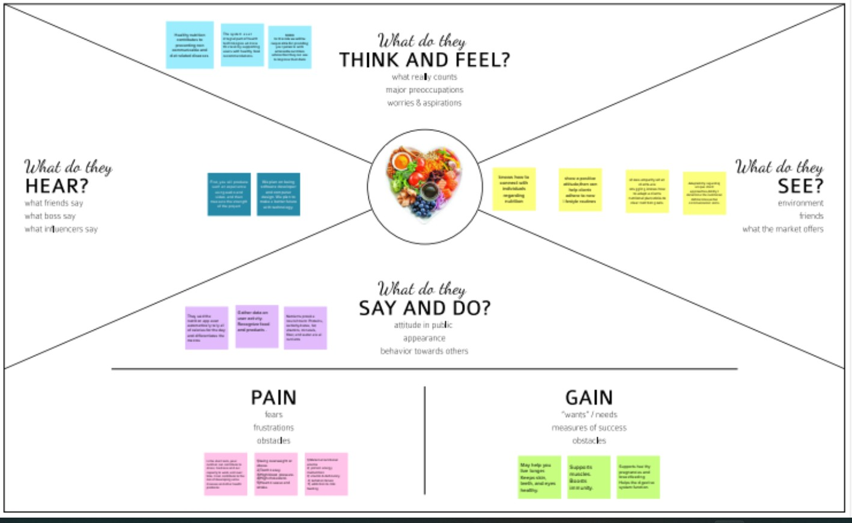

11

# 3.2 Ideation & Brainstorming:

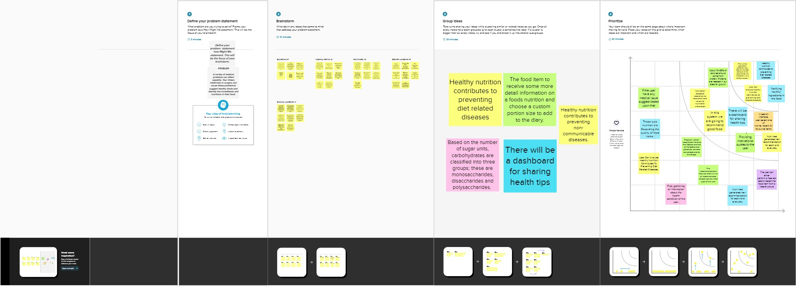

**3.3.Proposed Solution:**

This application provides the user with acomplex algorithm which can provide the user with a dietplan based on his/her characteristics like height, weight,BMI, gender etc. Everyone today dreams of healthy lifecycle.In Today’s busy life healthy body is dream for everyone tohave a proper balanced diet. A balanced diet is important because your organs and tissues need proper nutrition to work effectively. Without good nutrition, your body is more prone to disease, infection, fatigue, and poor performance. Children with a poor diet run the risk of growth and developmental problems and poor academic performance, and bad eating habits can persist for the rest of their lives. At the core of a balanced diet are foods that are low in unnecessary fats and sugars and high in vitamins, minerals, and other nutrients. The following food groups are essential parts of a balanced diet. Calories play a vital role in our growth and energy. A good diet can help you manipulate calorie intake based on your requirements. The proposed application will provide the user with a user-friendly User-Interface where they can create an account, manage their account and get the diet by the click of just one button. If the

12

user is allergic to some kind of food, it also has the feature to contact an actual dietitian to consult. And there’s also a page where the user can just read some interesting facts on health and human body. This application will save a lot of user’s time by not actually visiting a dietitian and getting everything done on their phone.

# Advantage of Proposed System :

* + - This application can be further improved by feedback suggestions from the users.
    - This application can be improved with the help of anexpert nutritionist who can help us creating different types of programs for different classification of users.
    - The project is easily extensible and can be improved by further incremental releases of the same.
    - We plan to focus on improving the overallperformance of the system. Also, interactionbetween guider and dietitian through video callingand secure prescription will be focused upon.

Some more ways to achieve dietitian will befocused.

# Problem Solution Fit :

It is simple to get sucked into the trap of consuming calorie-dense, unhealthy foods. Users must limit their daily calorie consumption in order to lead a healthy lifestyle since when foods with low nutritional value are replaced by those

13

high in sugar, unhealthy fats, and salt, numerous health problems result.

By taking a picture of the food and uploading it to the app, users may learn the nutritional value of the food they are consuming. For precise food recognition and APIs that provide the discovered item's nutritional value, Clarifai uses its AI- Driven food detection model.

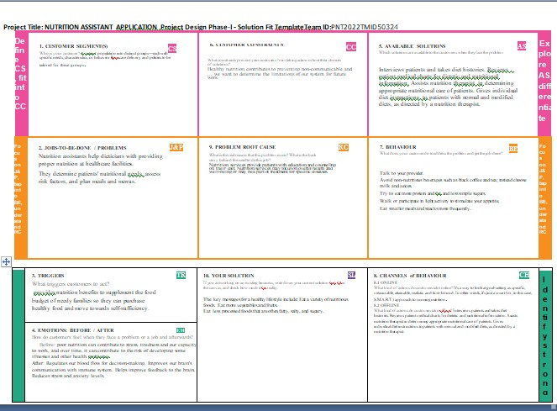

14

# Requirement Analysis

* 1. **Funtional Requirements**

|  |  |  |
| --- | --- | --- |
| **FR No** | **Functional Requirement (Epic)** | **Sub Requirement (Story /**  **Sub-Task)** |
| FR - 1 | User Registeration | Registration through form Registration through gmail  Registration through LinkedIN |
| FR - 2 | User Confirmation | Confirmation via Email  Confirmation via OTP |
| FR - 3 | User Login | Enter user pin |
| FR - 4 | Select Food Items | Food selection |
| FR - 5 | Calcuate Calorie | Total calorie |
| FR - 6 | Calculate Bmi | BMI |

* 1. **Non Functional Requirements**

|  |  |  |
| --- | --- | --- |
| **NFR**  **No** | **Non-Functional**  **Requirement** | **Description** |
| NFR-1 |  | However, there is scant research examining the user experience of different measurement approaches for mobile dietary reporting apps when dealing with a wide variety of food  shapes and container sizes |
| NFR-2 | Security | Nutrition security means having consistent  access, availability, and affordability of foods |

15

|  |  |  |
| --- | --- | --- |
|  |  | and beverages that promote well-being and prevent (and if needed, treat) disease, particularly among racial/ethnic minority populations, lower incomes populations, and  rural and remote populations. |
| NFR-3 | Reliability | Nutrition Data obtains food composition data from a variety of published and unpublished sources, with the largest provider of data being the USDA. While Nutrition Data cannot guarantee 100% accuracy, we do our best to  check or verify all data entries. |
| NFR-4 | Performance | The app will provide step -by -step guidelines for how and when every athlete should fuel  their body for optimizing their performance. |
| NFR-5 | Availability | Availability at all times of adequate world food supplies of basic foodstuffs to sustain a steady expansion of food consumption and to offset  fluctuations in production and prices. |
| NFR-6 | scalability | Scaling Up Nutrition is a global push for action and investment to improve maternal and child nutrition. Evidence shows that proper nutrition during the 1000 days between a woman's pregnancy and her child's second birthday  gives children a healthy start at life |

16

# PROJECT DESIGN

* 1. **Data Flow Diagram:**

A Data Flow Diagram (DFD) is a traditional visual representation of the information flows within a system. A neat and clear DFD can depict the right amount of the system requirement graphically. It shows how data enters and leaves the system, what changes the information, and where data is stored.

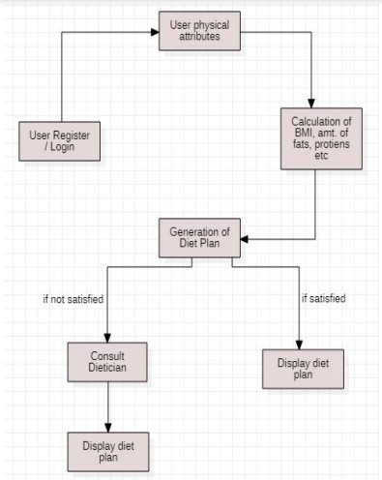

17

# Solution & Technical Architecture:

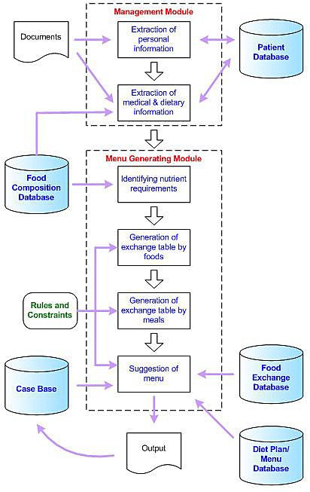

**Technical Architecture**

18

# User Stories

|  |  |  |  |  |  |  |
| --- | --- | --- | --- | --- | --- | --- |
| **User Type** | **Functional Requirem ent (Epic)** | **User Story Number** | **User Story / Task** | **Acceptance criteria** | **Priority** | **Release** |
| Customer (Mobile user) | Registrati on | USN-1 | As a user, I can register  for the  application by entering my email, password, and confirming  my password. | Ican access my account / dashboard | High | Sprint-1 |
|  |  | USN-2 | As a user, I will receive confirmation email once I have registered for the application | I can receive confirmation email & click confirm | High | Sprint-1 |
|  |  | USN-3 | As a user, I can register  for the | I can register & access the | Low | Sprint-2 |

19

|  |  |  |  |  |  |  |
| --- | --- | --- | --- | --- | --- | --- |
|  |  |  | application through Facebook | dashboard with Facebook  Login |  |  |
|  |  | USN-4 | As a user, I can register  for the  application through Gmail |  | Medium | Sprint-1 |
|  | Login | USN-5 | As a user, I can log into the application by entering email &  password |  | High | Sprint-1 |
|  | Dashboard |  |  |  |  |  |
| Customer (Web user) |  |  |  |  |  |  |
| Customer Care Executive |  |  |  |  |  |  |
| Administra tor |  |  |  |  |  |  |

20

|  |  |  |  |  |  |  |
| --- | --- | --- | --- | --- | --- | --- |
| 1. **PROJECT PLANNING AND SCHEDULING**    1. **Sprint Planning and Estimation** | | | | | | |
| **Sprint** | **Funct ional Requi reme nt (Epic)** | **User Story Numb er** | **User Story / Task** | **Story Points** | **Prior ity** | **Team Members** |
| Sprint-1 | Login | USN-1 | The user  will login  into the website and go through the products available  on the  website. | 20 | High | Suvetha P  Dhana LakshmiV  Gowri Lakshmi R  Pavithra M  Vishnu Priya M |
| Sprint-2 | Registrat ion | USN-2 | The user fill the Registration form. | 20 | High | Suvetha P  Dhana Lakshmi V  Gowri Lakshmi R  Pavithra M  Vishnu Priya |
| 21 | | | | | | |

|  |  |  |  |  |  |  |
| --- | --- | --- | --- | --- | --- | --- |
|  | | | | | | |
|  |  |  |  |  |  | M |
| Sprint-3 | Calories | USN-3 | User select the food and the Calories will calculate. | 20 | High | Suvetha P  Dhana Lakshmi V  Gowri Lakshmi R  Pavithra M  Vishnu Priya M |
| Sprint-4 | BMI | USN-4 | User give  their height  and weight after BMI will calculate. | 20 | High | Suvetha P  Dhana Lakshmi V  Gowri Lakshmi R  Pavithra M  Vishnu Priya M |
| 22 | | | | | | |

# Project Estimation

|  |  |  |  |  |  |  |  |  |  |
| --- | --- | --- | --- | --- | --- | --- | --- | --- | --- |
| **Sprint** | **Total Story Poin ts** | **Durati on** | **Sprint Start Date** | | **Spri nt End Date (Plan ned)** | | **Story Points**  **Comple ted (as on Plann ed End Date)** | **Spri nt Rele ase Date (Act ual)** | |
| Sprint-1 | 20 | 6 Days | 24  2022 | Oct | 29 Oct 2022 | | 20 | 29  2022 | Oct |
| Sprint-2 | 20 | 6 Days | 31  2022 | Oct | 05  2022 | Nov | 20 | 05  2022 | NOV |
| Sprint-3 | 20 | 6 Days | 07  2022 | Nov | 12  2022 | Nov | 20 | 12  2022 | NOV |
| Sprint-4 | 20 | 6 Days | 14  2022 | Nov | 19  2022 | Nov | 20 | 19  2022 | NOV |

23

# Sprint Delivery Schedule

|  |  |  |
| --- | --- | --- |
| **Title** | **Description** | **Date** |
| Literature Survey & Information Gathering | Literature survey on the selected project & gathering information by referring the, technical  papers, research publications | 22 October 2022 |
| Prepare Empathy Map | Prepare Empathy Map Canvas to capture the user Pains & Gains, Prepare list of problem  statements | 12 September 2022 |
| Ideation | List the by organizing the brainstorming session and prioritize the top 3 ideas based  on the feasibility & importance | 23 October2022 |
| Proposed Solution | Prepare the proposed solution document, which includes the novelty, feasibility of idea,  business model,  social impact, scalability of solution, etc | 20 October 2022 |
|  | Prepare problem solution |  |

24

|  |  |  |
| --- | --- | --- |
| Problem Solution Fit | fit document | 21 October 2022 |
| Solution Architecture | Prepare solution architecture  document | 25 October 2022 |
| Customer Journey | Prepare the customer journey maps to understand the user interactions & experiences with  the application | 28 October 2022 |
| Functional Requirement | Prepare the functional requirement document | 28 October 2022 |
| Data Flow Diagrams | Draw the data flow diagrams and  submit for review | 28 October 2022 |
| Technology Architecture | Prepare the technology architecture diagram | 28 October 2022 |
| Prepare Milestone & Activity List | Prepare the milestones & activity  list of the project | 29 October 2022 |

25

# Report From Jira

**47.CODING AND SOLUTIONING**

**7.1. Feature**

26

# User Login Page

The login page allows a user to gain access to an application by entering their username and password or by authenticating using a social media login.

* A user navigates to an application and is presented with a login page as a way to gain access to the application. There are two possible results:

 Authentication is successful and the user is directed to the application landing

page.

 Authentication fails and the user remains on the login page. If authentication fails, the screen should show an informational or error message about the failure.

* A user is automatically logged out due to inactivity. In this event, they will be returned to the login page, which will display an informational Tmessage explaining what happened. Once the user logs in again, they should be taken back to the page they were previously on before being timed out. Thirty minutes is the suggested duration before a session timeout, but this is subject to change based on your product’s security requirements.

# User Registeration Page

All customers that have created online account need to provide customer registration information, which is used to capture customer profile as well as generate and issue commercial registration certificate. After logging-in to the system for the first time, customers are provided with a wizard-like interface that allows them to provide information required for capturing customer profile and generating commercial registration certificate.

# Calorie Calculation :

27

The cornerstone of any good fitness plan is getting your diet right, and to do that, the first thing you need to do is to determine what your daily calorie needs are.

There are a lot of different online calculators you can use to find out how many calories you should eat per day. Some of them are ok, but most calorie calculators oversimplify by only using your age, weight, and gender (and perhaps BMI).

If you are a fitness nerd like me, you will probably want to know the correct scientific way of calculating what your daily calorie needs are.

It’s a very easy 5-step process. I have used my own data in the example below to show you how I work out what my daily calorie needs are.

# How to calculate your daily calorie needs :

You can calculate your daily “maintenance calories” by following these easy steps:

Step 1: Find your current body weight in kilograms (if you live in the US, just divide your current weight in pounds by 2.2 to get your weight in kilograms).

Step 2: Multiply your weight in kilograms by 0.9 if you are a woman or 1.0 if

you are a man.

Step 3: Multiply by 24

Step 4: Multiply by your “Lean Factor” from the table below (read on to learn how to find your body fat percentage if you don’t know it)

28

Step 5: Multiply by Activity Modifier

Important: No matter what this formula says, never eat less than 1,200 calories per day on average without consulting your medical team first. A very low daily calorie intake can lead to a slower metabolism, hormonal problems, and a number of [other medical issues.](https://pubmed.ncbi.nlm.nih.gov/33677461/)

For example: My daily calorie need would be: 1252 (my BMR) x 1.55 (Light Activity) = 1940 calories/day

# BMI Calculation :

A person’s Body-Mass Index, or BMI, helps them check whether they’re a healthy weight for their height. If a person weighs less or more than the recommended weight for their height, it could lead to health issues in the future. While BMI is not the only factor individuals should consider while working on their health and fitness, it is a good starting point. To understand what your BMI is, you need to know your height and weight. You can then use an online BMI calculator to check your BMI, which will help you understand if you’re underweight, a healthy weight, overweight or obese. Or, you can measure your height in metres and weight in kilograms. Divide your weight by your height squared to calculate your BMI.

29

# TESTING

* 1. **Testcases**

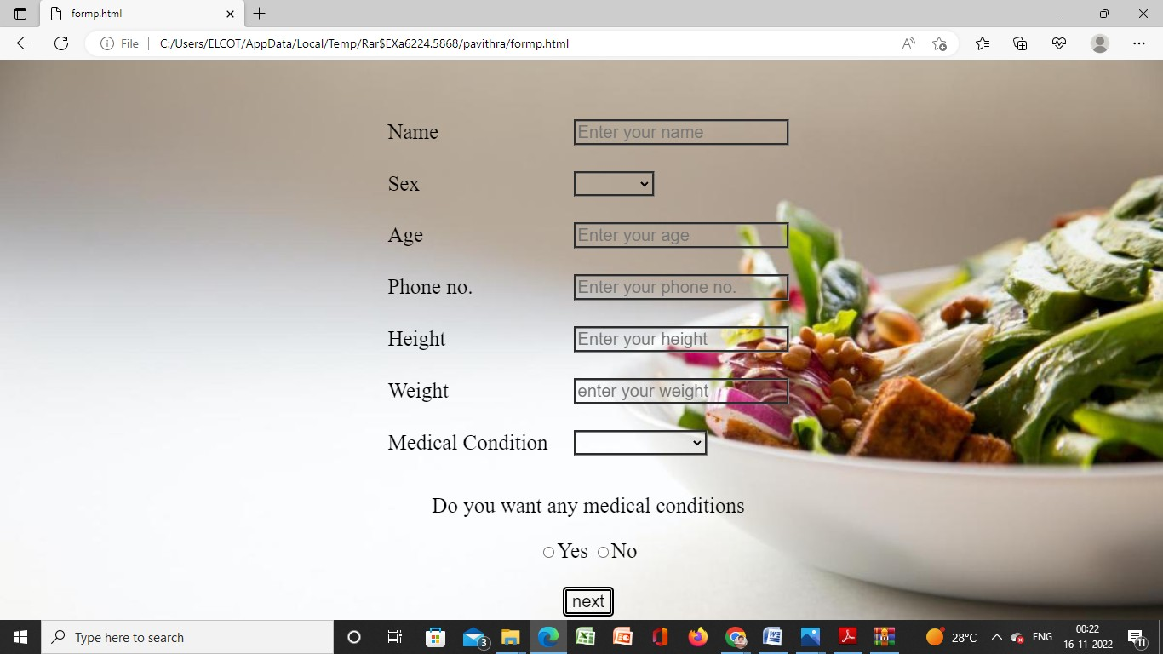

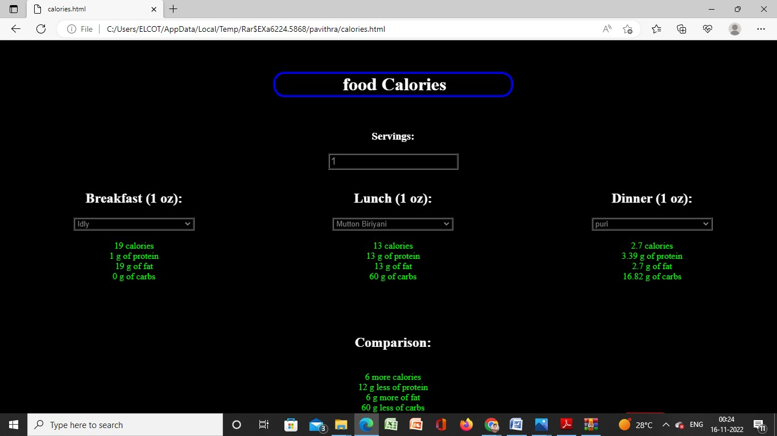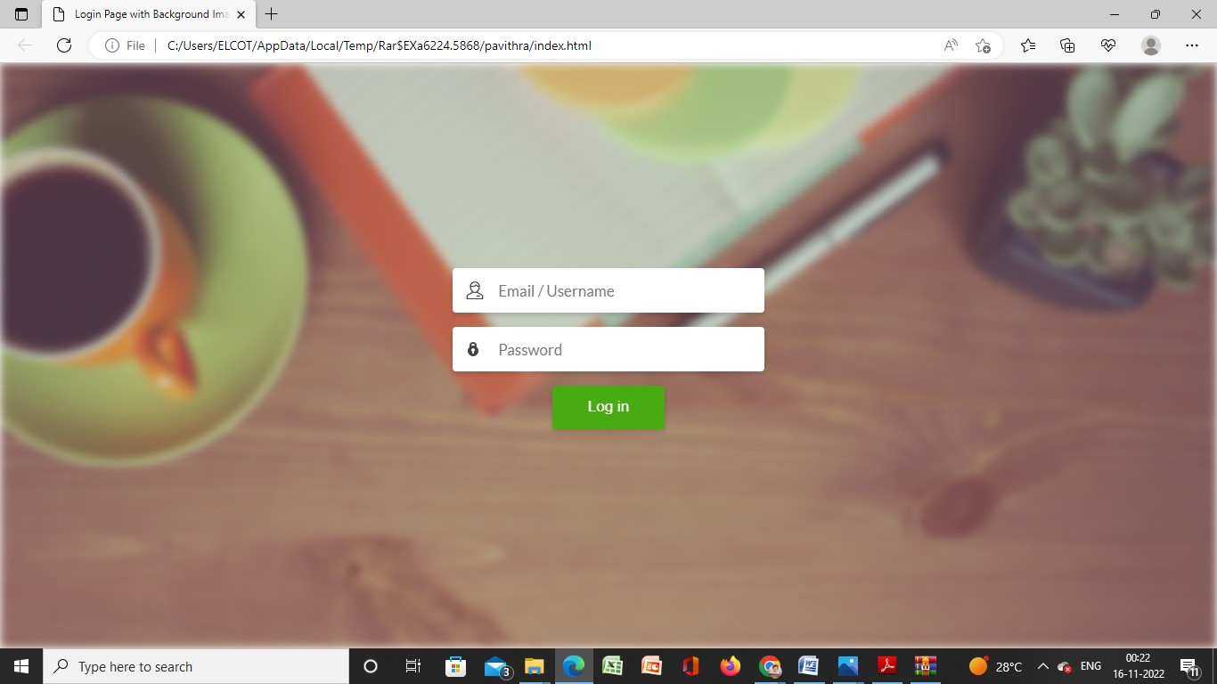

30



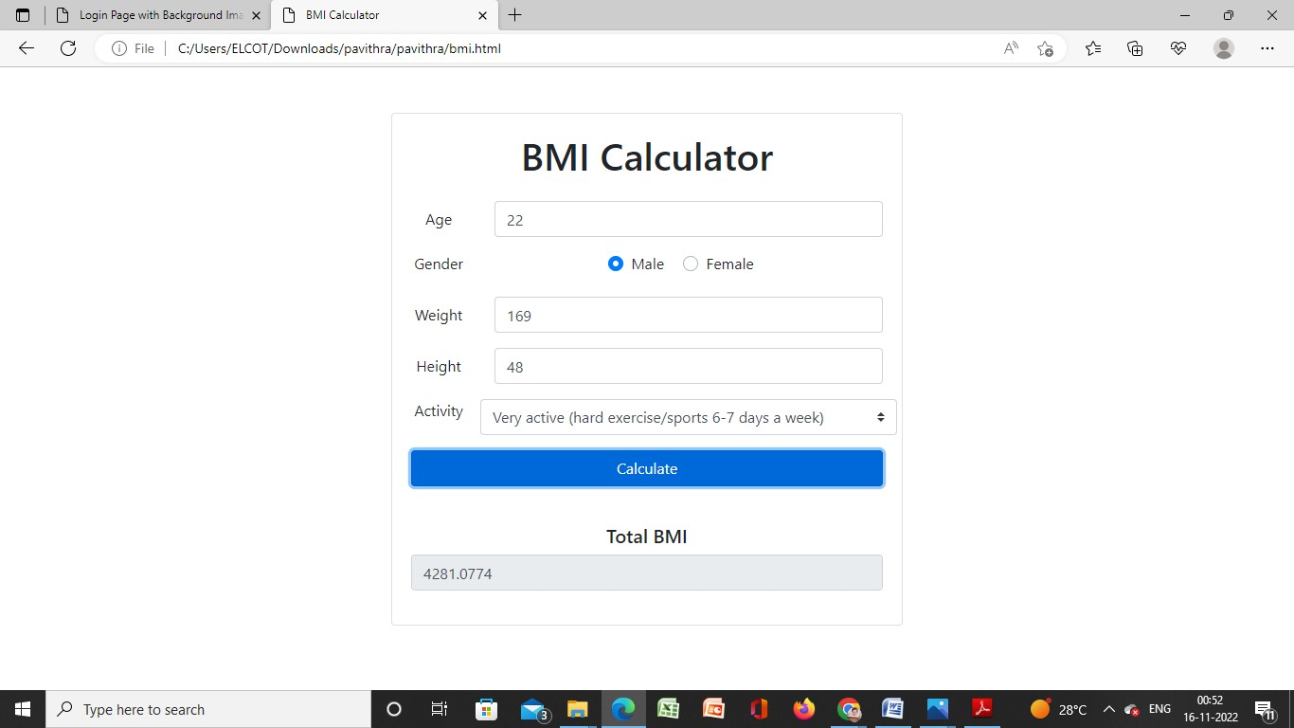

31

# Testing

Testing is a process, which reveals errors in the program.It is the major quality measure employed during software development. During software development.During testing, the program is executed with a set of test cases and the output of the program for the test cases is evaluated to determine if the program is performing as it is expected to perform.

In order to make sure that the system does not haveerrors, the different levels of testing strategies that are applied at differing phases of software development are:

# Unit Acceptance Testing

User acceptance testing (UAT), also called application testing or end- user testing, is a phase of software development in which the software is tested in the real world by its intended audience. UAT is often the last phase of the software testing process and is performed before the tested software is released to its intended market. The goal of UAT is to ensure software can handle real-world tasks and perform up to development specifications.

In UAT, users are given the opportunity to interact with the software before its official release to see if any features have been overlooked or if it contains any bugs. UAT can be done in-house with volunteers, by paid test subjects using the software or by making the test version available for download as a free trial. The results from the early testers are forwarded to the developers, who

32

make final changes before releasing the software commercially.

UAT is effective for ensuring quality in terms of time and software cost, while also increasing transparency with users. UAT also enables developers to work with real cases and data, and if successful, the process can validate business requirements.

33

# RESULTS

**9.1. Performance Metrics**

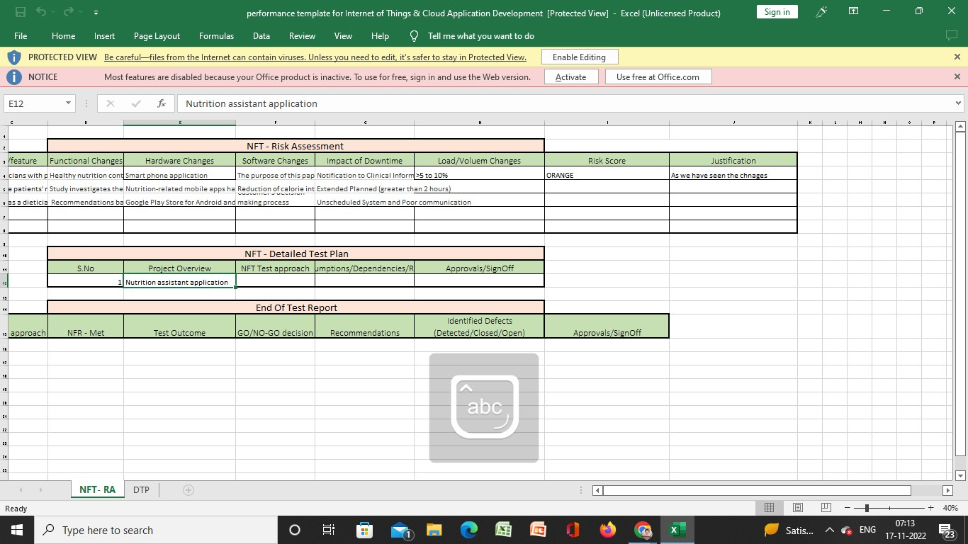

34

# ADVANTAGES AND DISADVANTAGES

* 1. **Advantages**

A healthy diet throughout life promotes healthy pregnancy outcomes, supports normal growth, development and ageing, helps to maintain a healthy body weight, and reduces the risk of chronic disease leading to overall health and well-being.

* + - Improved efficiency and speed – The healthcare apps can enhance healthcare delivery with more efficiency, as they can handle multiple queries and requirements at a time.
    - Reduction in healthcare costs – The cost associated with the healthcare consultation reduced significantly with the usage of apps as the maintenance cost is less.
    - Save time – With the healthcare apps, the patients can easily connect with the healthcare provider for consultation. It saves traveling time between home and the healthcare center and also requires fewer visits as compared to the traditional approach.

# Disadvantages

* + - Data Privacy – The health apps continuously collect and analyze the health data of the person. The threat to the exposure of personal information by the hacker and sharing with the third parties is a major concern. Over the past few years, in several stances, news and updates regarding the leakage of health data have been reported by the reported apps manufacturers.
    - Accuracy of Data – The information and advice provided by healthcare apps is also an important concern with healthcare apps. Different apps use different methods and tools to analyze health data. In some cases, the data measured with the apps are found to be varying when compared with the MedTech devices

35

# CONCLUSION

Based on the research and design of this, it can be concluded:

This application is designed to help users todetermine the condition of the body, as well asthe number of calories needed to tell users howmuch calories from food eaten.

The application is designed using eclipseprogram, and runs on smartphones that use the Android operating system.

# FUTURE SCOPE

Applications built certainly still have manyshortcomings, therefore there are some things that might be developed for these applications to be better and more useful, namely:

* Applications can be developed so that it has anonline update system. System update function toadd food database and data on the number of calories contained.
* Applications are still running on the Androidoperating system only. For future developmentmay be made on other operating systems (e.g.IOS).
* Added a menu that gives information about thetypes of diet that exist, and how to run it.

36

# APPENDIX

**Source Code**

**INDEX.html**

<!DOCTYPE html>

<html lang="en">

<head>

<meta charset="UTF-8">

<title>Login Page with Background Image Example</title>

<link rel="stylesheet" href="style.css">

</head>

<body>

<!-- partial:index.partial.html -->

<div id="bg"></div>

<form action="formp.html" method="post">

<div class="form-field">

<input type="email" placeholder="Email / Username" required/>

</div>

<div class="form-field">

<input type="password" placeholder="Password" required/> </div>

<div class="form-field">

button class="btn" type="submit">Log in</button>

</div>

</form>

<!-- partial -->

</body>

</html>

# FORM.html

<html>

<head>

<style>

37

body {

background-image: url('https://[www.expatrio.com/sites/default/files/styles/image_slider/public/2022-](http://www.expatrio.com/sites/default/files/styles/image_slider/public/2022-) 05/hermes-rivera-Ww8eQWjMJWk-unsplash_3.jpg?itok=aqyA4cvZ');

position: fixed; left: 0;

top: 0;

width: 100%;

height: 100%; background-size: cover;

}

form {

margin-top: 3%; font-size: 25px;

}

table {

font-size: 25px;

}

input, select, option {

font-size: 20px;

background-color: transparent; color: black;

border: 3px groove gray; cursor: pointer;

}

button {

border: 5px double black; border-radius: 5px; padding-left: 6px; columns: rgb(159, 1, 1);

38

background: transparent; font-size: 20px;

cursor: pointer;

}

button:hover {

border: 5px groove red; border-radius: 5px; padding-left: 6px; columns: rgb(3, 3, 3); background: gray;

font-size: 20px; cursor: pointer;

}

</style>

</head>

<body>

<div id="bg"></div>

<form action="calories.html" method="post">

<center>

<table cellpadding="10" cellspacing="10">

<tr>

<td>Name</td>

<td><input type="text" name="name" placeholder="Enter your name" required></td>

</tr>

<tr>

<td>Sex</td>

<td><select required>

<option value=""></option>

<option value="male">Male</option>

<option value="female">Female</option>

</select></td>

39

</tr>

<tr>

<td>Age</td>

<td><input type="tel" name="age" pattern="[0-9]{2}" placeholder="Enter your age" required> </td>

</tr>

<tr>

<td>Phone no.</td>

<td><input type="tel" name="number" pattern="[0-9]{10}" placeholder="Enter your phone no." required></td>

</tr>

<tr>

<td>Height</td>

|  |  |  |  |  |
| --- | --- | --- | --- | --- |
| <td><input type="number"  required></td> | name="height" | placeholder="Enter | your | height" |
| </tr> |  |  |  |  |
| <tr> |  |  |  |  |
| <td>Weight</td> |  |  |  |  |
| <td><input type="number" | name="weight" | placeholder="enter | your | weight" |
| required></td> |  | | | |
| </tr> |
| <tr> |
| <td>Medical Condition</td> |
| <td> |
| <select required> |
| <option value=""></option> |

<option value="diabetes">Diabetes</option>

<option value="pre-diabetes">Pre-Diabetes</option>

<option value="hypertension">Hypertension</option>

<option value="pcos">PCOS</option>

<option value="thyroid">Thyroid</option>

<option value="physical injury">Physical Injury</option>

40

<option value="sleep issue">Sleep issue</option>

<option value="depression">Depression</option>

<option value="anger issue">Anger Issue</option>

<option value="loneliness">Loneliness</option>

</select>

</td>

</tr>

</table>

<p>Do you want any medical conditions </p>

<input type="radio" name="nutri" id="yes" value="yes">Yes

<input type="radio" name="nutri" id="no" value="No">No<br><br>

<button>next</button>

</center>

</form>

</body>

</html>

# CALORIES.html

<html>

<head>

<link rel="stylesheet" href="calories.css">

</head>

<body>

<center>

<h1>food Calories</h1><br>

<label>

<h3>Servings:</h3>

<input type="number" id="numberOfStocks" value="1" min="0" />

</label><br><br>

<div>

<div class="side">

<h2>Breakfast<span class="servingUnit"></span>:</h2>

41

<select class="selectStock">

<option value="-1">Pick a food!</option>

</select>

<br>

<br>

<div class="result"></div>

</div>

<div class="side">

<h2>Lunch<span class="servingUnit"></span>:</h2>

<select class="selectStock">

<option value="-1">Pick a food!</option>

</select>

<br>

<br>

<div class="result"></div>

</div>

<div class="side">

<h2>Dinner<span class="servingUnit"></span>:</h2>

<select class="selectStock">

<option value="-1">Pick a food!</option>

</select>

<br>

<br>

<div class="result"></div>

</div>

</div>

<div class="comparison">

<h2>Comparison:</h2>

<br>

<div class="result"></div>

</div>

</center>

42

<form action="bmi.html" method="post">

<button>Next</button>

</form>

<script src="https://ajax.googleapis.com/ajax/libs/jquery/2.1.1/jquery.min.js"></script>

<script type="text/javascript" src="js/calory.js"></script>

</body>

</html>

# BMI.html

<!doctype html>

<html lang="en">

<head>

<!-- Required meta tags -->

<meta charset="utf-8">

<meta name="viewport" content="width=device-width, initial-scale=1, shrink-to- fit=no">

<!-- Bootstrap CSS -->

<link rel="stylesheet"

href="https://stackpath.bootstrapcdn.com/bootstrap/4.5.2/css/bootstrap.min.css" integrity="sha384- JcKb8q3iqJ61gNV9KGb8thSsNjpSL0n8PARn9HuZOnIxN0hoP+VmmDGMN5t9 UJ0Z" crossorigin="anonymous">

<title>Calorie Calculator</title>

<style> #loading, #results { display: none;

}

#loading { width: 100%;

}

43

</style>

</head>

<body>

<div class="container">

<div class="row">

<div class="col-lg-6 mx-auto">

<div class="card card-body text-center mt-5">

<h1 class="heading display-5 pb-3">BMI Calculator</h1>

<form id="calorie-form">

<div class="form-group row">

<label for="age" class="col-sm-2 col-form-label">Age</label>

<div class="col-sm-10">

<input type="number" class="form-control" id="age" placeholder="Ages 15-80" required>

</div>

</div>

<fieldset class="form-group">

<div class="row">

<legend class="col-form-label col-sm-2 pt-0">Gender</legend>

<div class="col-sm-10" id="form-radio">

<div class="custom-control custom-radio custom-control-inline">

<input type="radio" id="male" name="customRadioInline1" class="custom- control-input" checked="checked">

<label class="custom-control-label" for="male">Male</label>

</div>

<div class="custom-control custom-radio custom-control-inline">

<input type="radio" id="female" name="customRadioInline1" class="custom- control-input">

<label class="custom-control-label" for="female">Female</label>

</div>

</div>

</div>

44

</fieldset>

<div class="form-group row">

<label for="weight" class="col-sm-2 col-form-label">Weight</label>

<div class="col-sm-10">

<input type="number" class="form-control" id="weight" placeholder="In kilograms" required>

</div>

</div>

<div class="form-group row">

<label for="height" class="col-sm-2 col-form-label">Height</label>

<div class="col-sm-10">

<input type="number" class="form-control" id="height" placeholder="In centimeters" required>

</div>

</div>

<div class="form-group row">

<legend class="col-form-label col-sm-2 pt-0">Activity</legend>

<select class="custom-select col-sm-10" id="list" required>

<option selected value="1">Sedentary (little or no exercise)</option>

<option value="2">Lightly active (light exercise/sports 1-3 days/week)</option>

<option value="3">Moderately active (moderate exercise/sports 3-5 days/week)</option>

<option value="4">Very active (hard exercise/sports 6-7 days a week)</option>

<option value="5">Extra active (very hard exercise/sports & physical job or 2x training)</option>

</select>

</div>

<div class="form-group">

<input type="submit" value="Calculate" class="btn btn-primary btn-block">

</div>

</form>

<div id="loading">

45

<img src="./img/Loading.gif" alt="">

</div>

<div id="results" class="pt-4">

<h5>Total BMI</h5>

<div class="form-group">

<div class="input-group">

<input type="number" class="form-control" id="Total-BMI" disabled>

</div>

</div>

</div>

</div>

</div>

</div>

</div>

<script src="https://code.jquery.com/jquery-3.5.1.slim.min.js" integrity="sha384- DfXdz2htPH0lsSSs5nCTpuj/zy4C+OGpamoFVy38MVBnE+IbbVYUew+OrCXa Rkfj" crossorigin="anonymous"></script>

<script src="[https://cdn.jsdelivr.net/npm/popper.js@1.16.1/dist/umd/popper.min.js](https://cdn.jsdelivr.net/npm/popper.js%401.16.1/dist/umd/popper.min.js)" integrity="sha384- 9/reFTGAW83EW2RDu2S0VKaIzap3H66lZH81PoYlFhbGU+6BZp6G7niu735Sk

7lN" crossorigin="anonymous"></script>

<script src="https://stackpath.bootstrapcdn.com/bootstrap/4.5.2/js/bootstrap.min.js" integrity="sha384- B4gt1jrGC7Jh4AgTPSdUtOBvfO8shuf57BaghqFfPlYxofvL8/KUEfYiJOMMV+r V" crossorigin="anonymous"></script>

<script src="js/script.js"></script>

</body>

</html>

46

# Github Link

[IBM-EPBL](https://github.com/IBM-EPBL)/[**IBM-Project-54549-1662216836**](https://github.com/IBM-EPBL/IBM-Project-48171-1660805120)

**Demo link:**

[**http://drive.google.com/file/d/13trnq47-01NikT94PL0lpRv7OiKCGe**](http://drive.google.com/file/d/13trnq47-01NikT94PL0lpRv7OiKCGe)**O_/view?usp=drivesdk**

47